

**Names:**

Muhammad Ali

RCF-30025

Hassan Abbas

Nasir khan

**Date:**

10/22/2023

**Submitted To:**

Mam Sobia

**Course:**

Artificial Intelligence

**NumPy Exercise**

1. [**Import numpy as np and see the version**](https://www.kaggle.com/python10pm/learn-numpy-the-hard-way-70-exercises-solutions#q1)

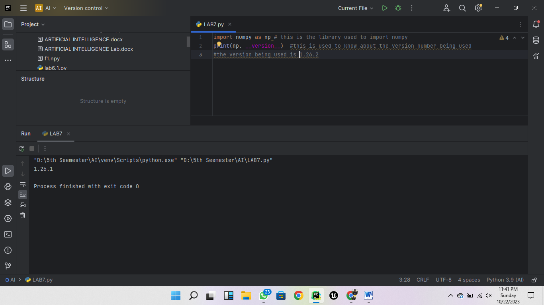

1. [**How to create a 1D array?**](https://www.kaggle.com/python10pm/learn-numpy-the-hard-way-70-exercises-solutions#q2)

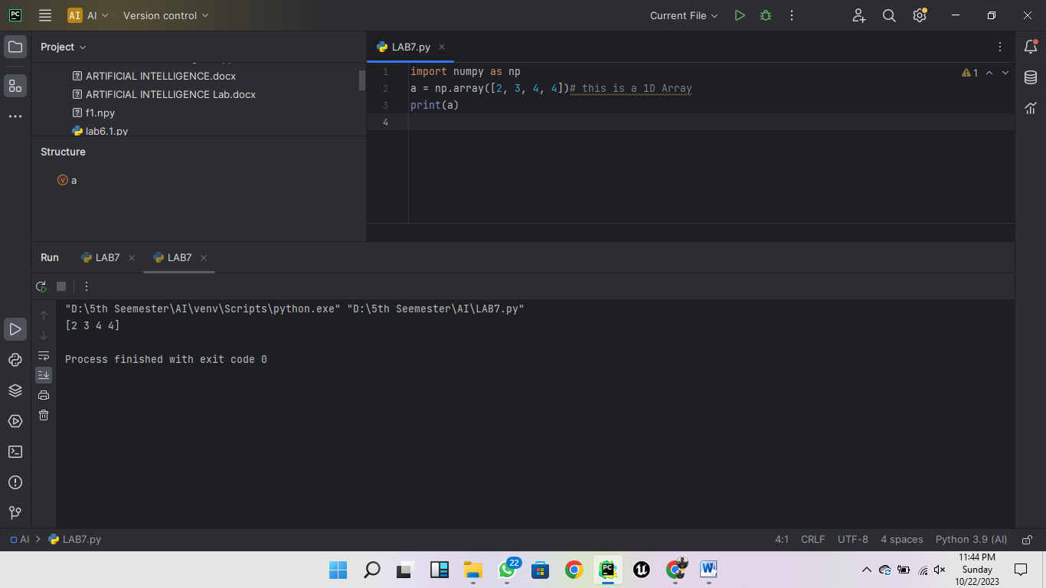

1. [**How to create a boolean array?**](https://www.kaggle.com/python10pm/learn-numpy-the-hard-way-70-exercises-solutions#q3)

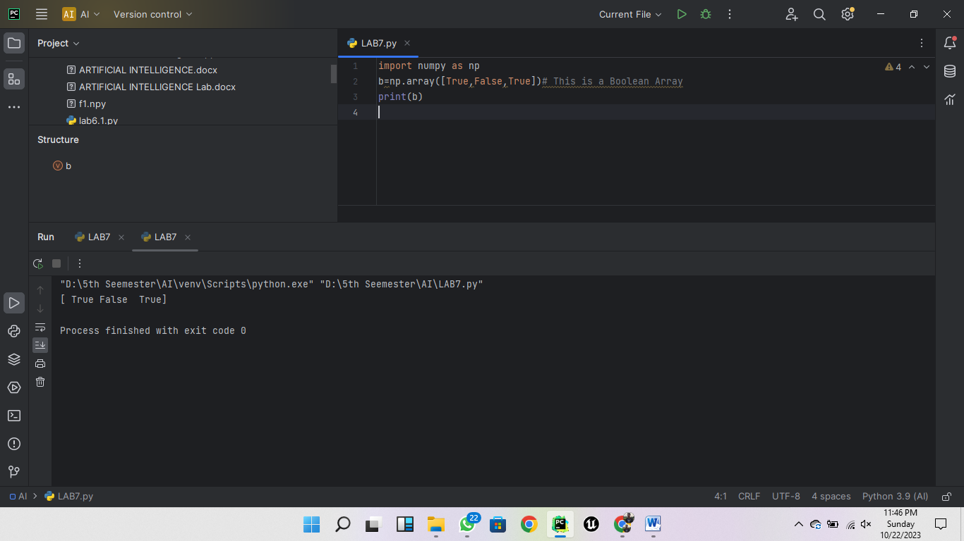

1. [**How to extract items that satisfy a given condition from 1D array?**](https://www.kaggle.com/python10pm/learn-numpy-the-hard-way-70-exercises-solutions#q4)

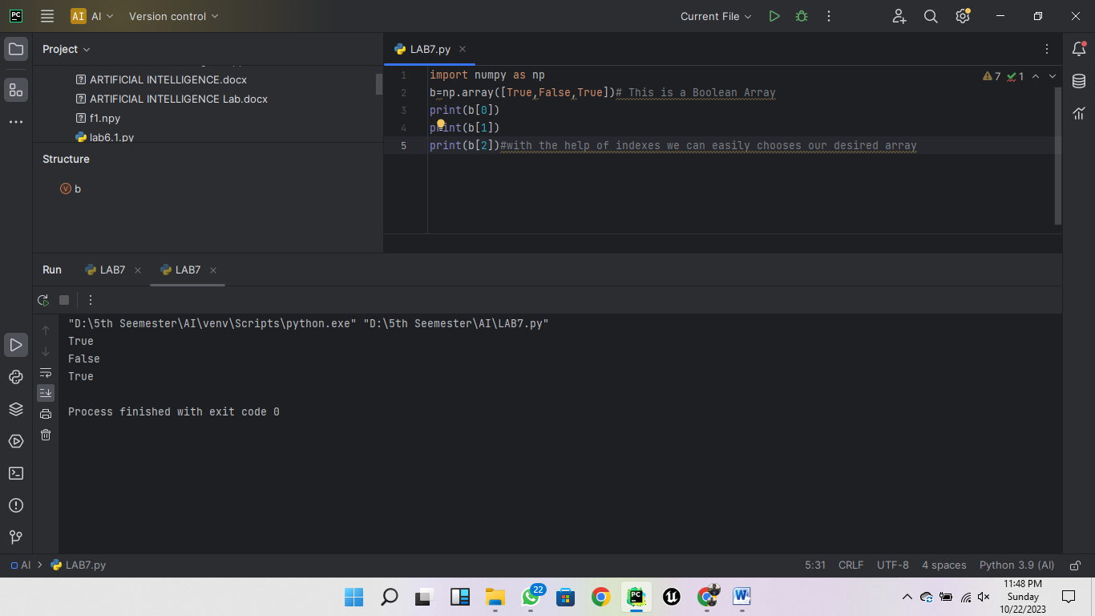

1. [**How to replace items that satisfy a condition with another value in numpy array?**](https://www.kaggle.com/python10pm/learn-numpy-the-hard-way-70-exercises-solutions#q5)

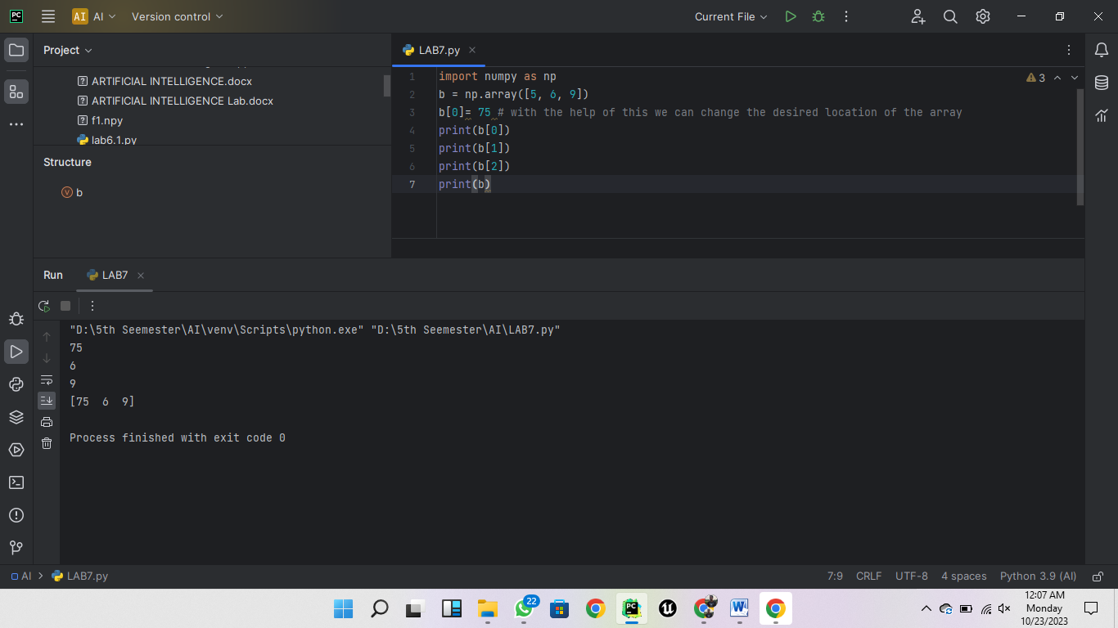

1. [**How to replace items that satisfy a condition without affecting the original array?**](https://www.kaggle.com/python10pm/learn-numpy-the-hard-way-70-exercises-solutions#q6)

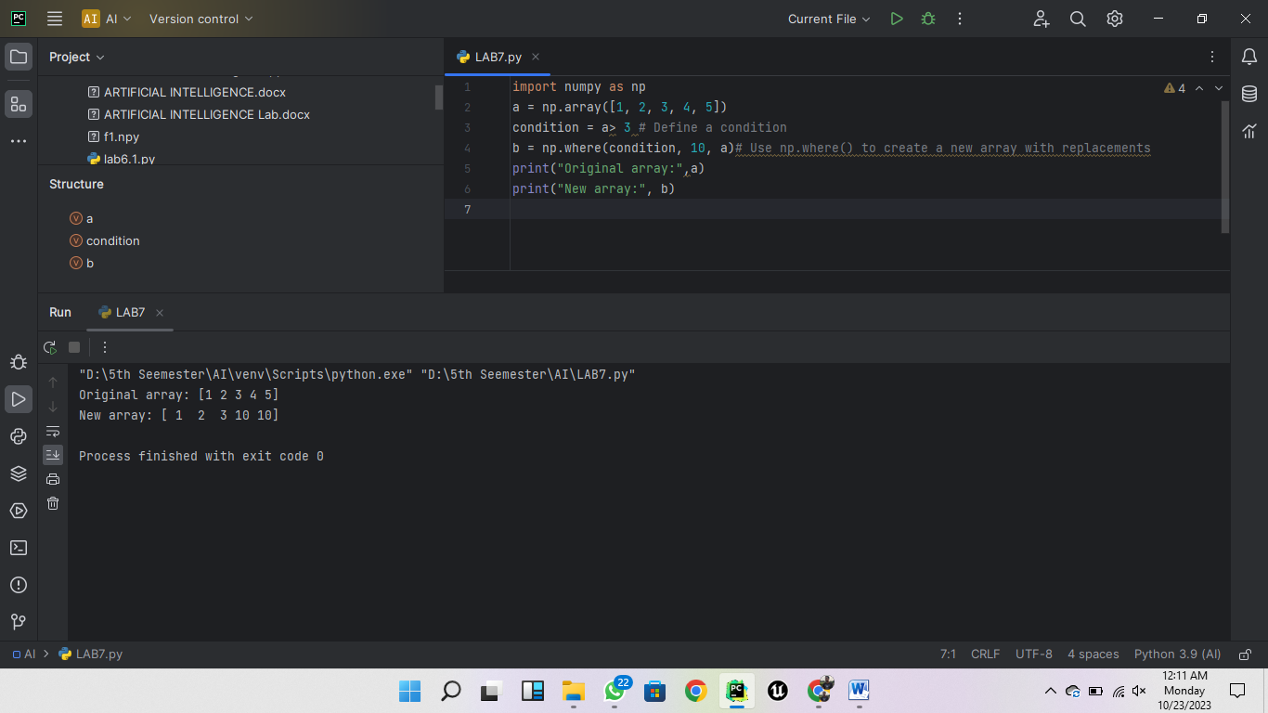

1. [**How to reshape an array?**](https://www.kaggle.com/python10pm/learn-numpy-the-hard-way-70-exercises-solutions#q7)

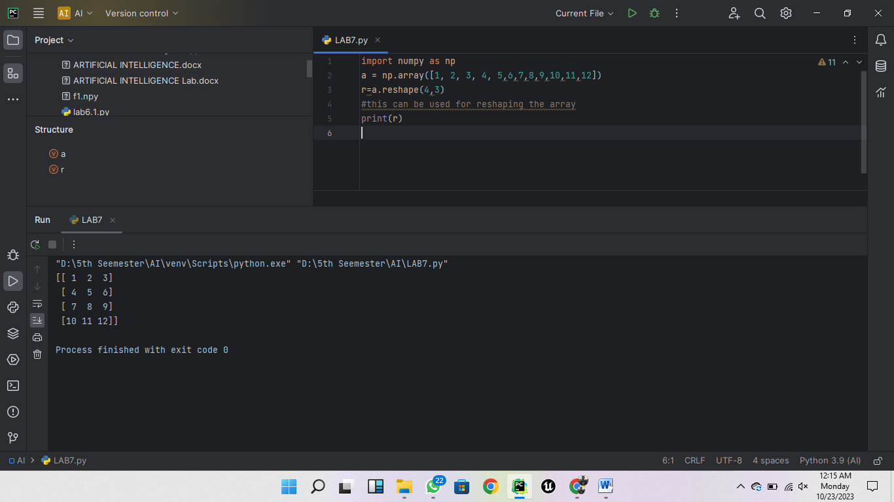

1. [**How to stack two arrays vertically?**](https://www.kaggle.com/python10pm/learn-numpy-the-hard-way-70-exercises-solutions#q8)

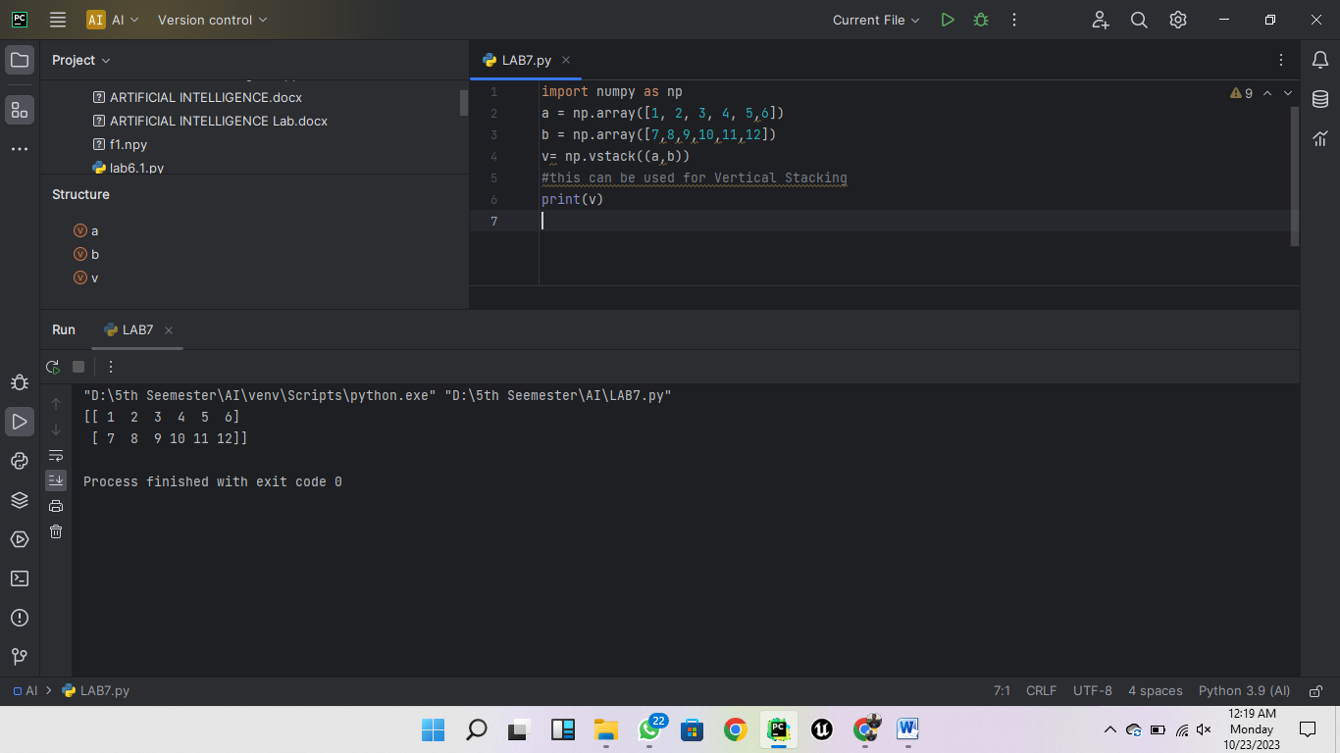

1. [**How to stack two arrays horizontally?**](https://www.kaggle.com/python10pm/learn-numpy-the-hard-way-70-exercises-solutions#q9)

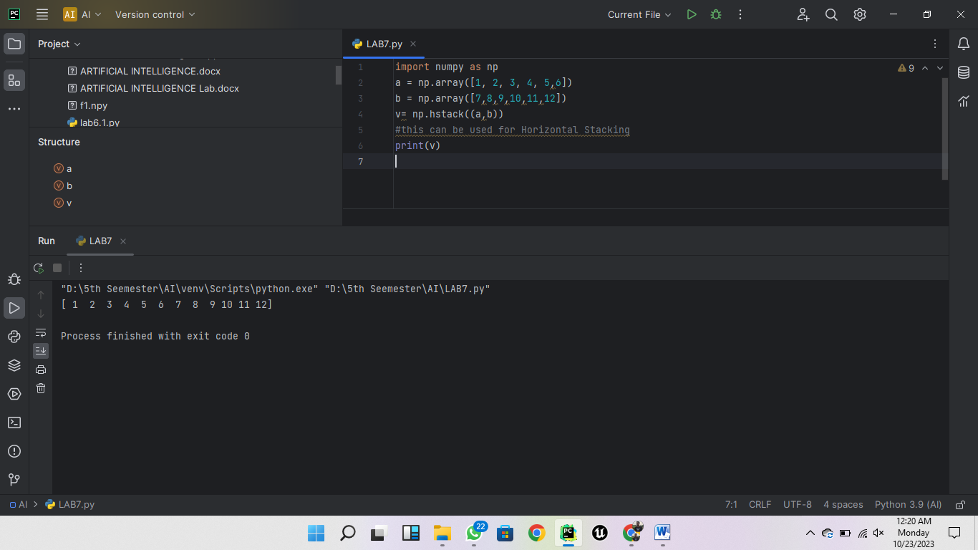

1. [**How to generate custom sequences in numpy without hardcoding?**](https://www.kaggle.com/python10pm/learn-numpy-the-hard-way-70-exercises-solutions#q10)

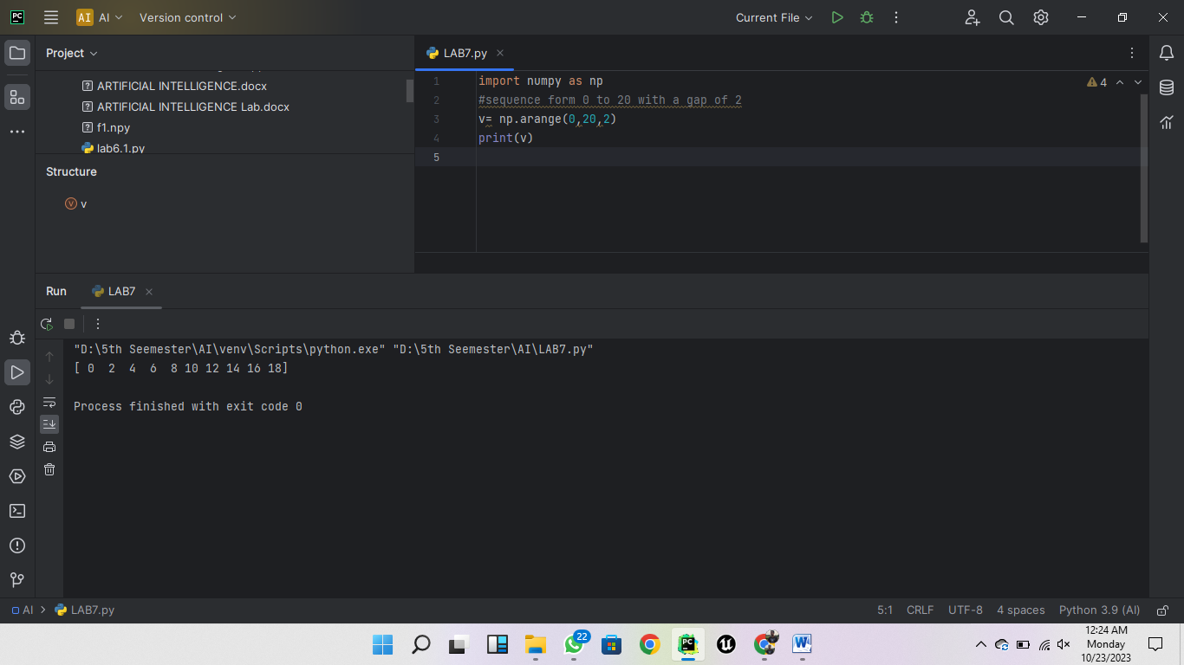

1. [**How to get the common items between two python numpy arrays?**](https://www.kaggle.com/python10pm/learn-numpy-the-hard-way-70-exercises-solutions#q11)

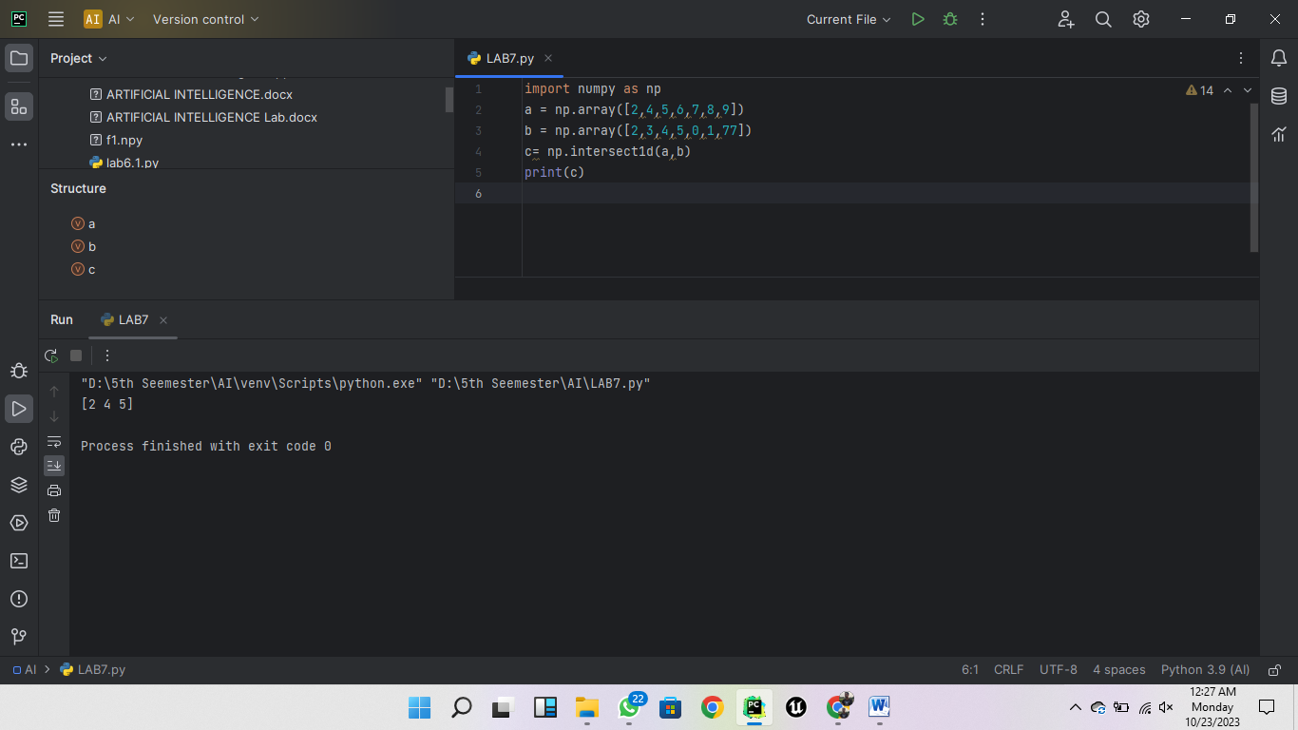

1. [**How to remove from one array those items that exist in another?**](https://www.kaggle.com/python10pm/learn-numpy-the-hard-way-70-exercises-solutions#q12)

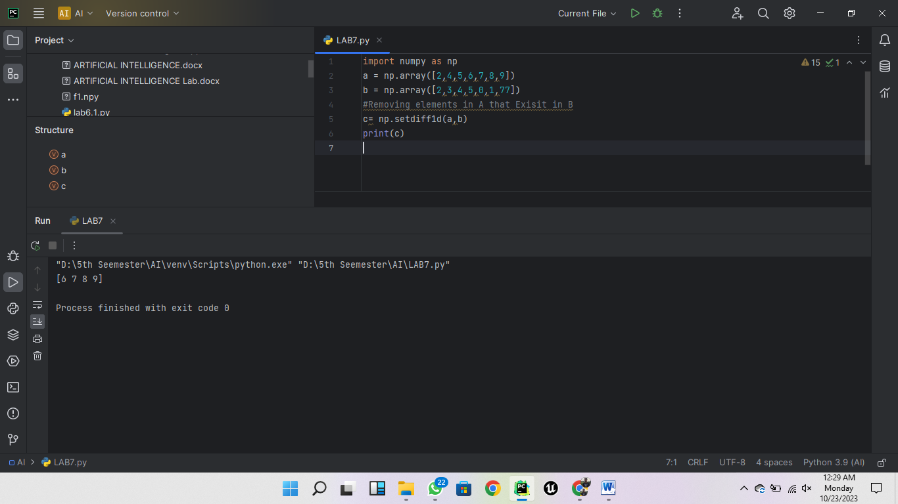

1. [**How to get the positions where elements of two arrays match?**](https://www.kaggle.com/python10pm/learn-numpy-the-hard-way-70-exercises-solutions#q13)

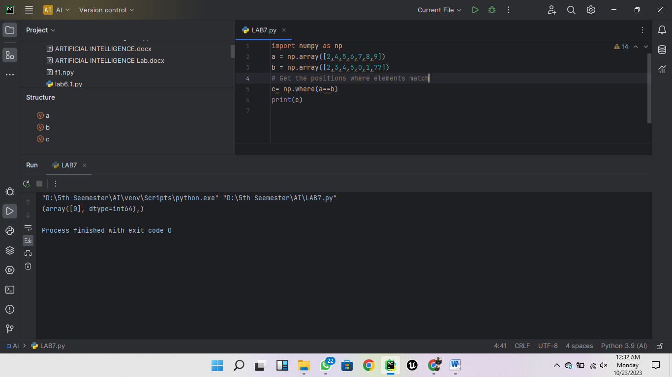

1. [**How to extract all numbers between a given range from a numpy array?**](https://www.kaggle.com/python10pm/learn-numpy-the-hard-way-70-exercises-solutions#q14)

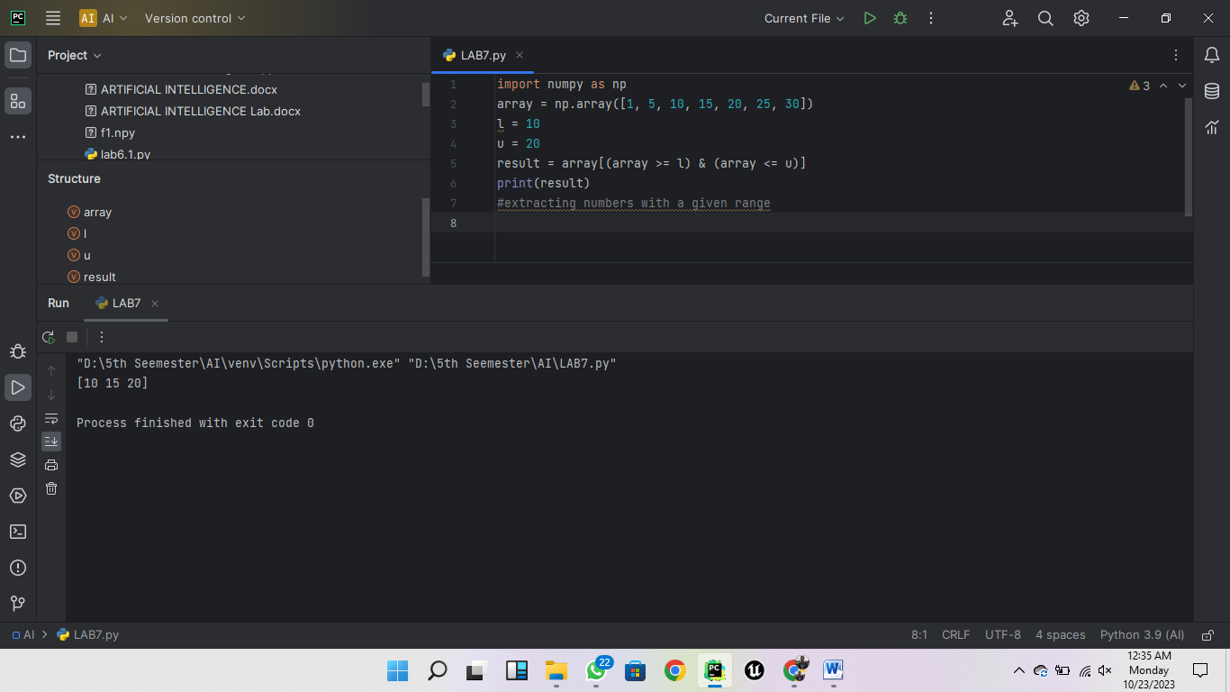

1. [**How to make a python function that handles scalars to work on numpy arrays?**](https://www.kaggle.com/python10pm/learn-numpy-the-hard-way-70-exercises-solutions#q15)

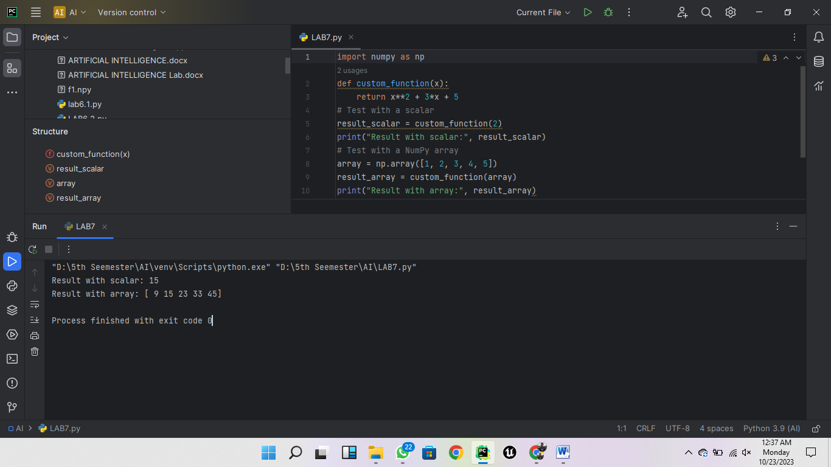

1. [**How to swap two columns in a 2d numpy array?**](https://www.kaggle.com/python10pm/learn-numpy-the-hard-way-70-exercises-solutions#q16)

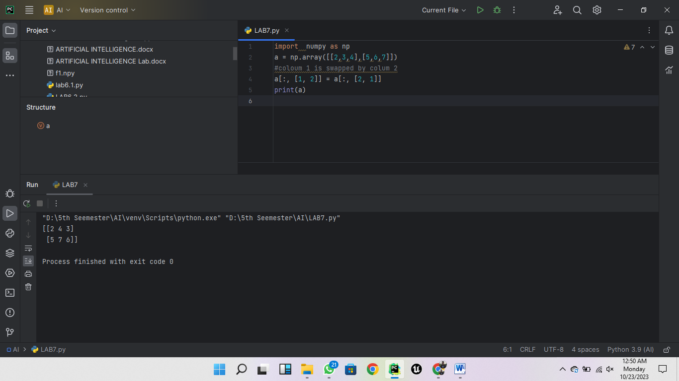

1. [**How to swap two rows in a 2d numpy array?**](https://www.kaggle.com/python10pm/learn-numpy-the-hard-way-70-exercises-solutions#q17)

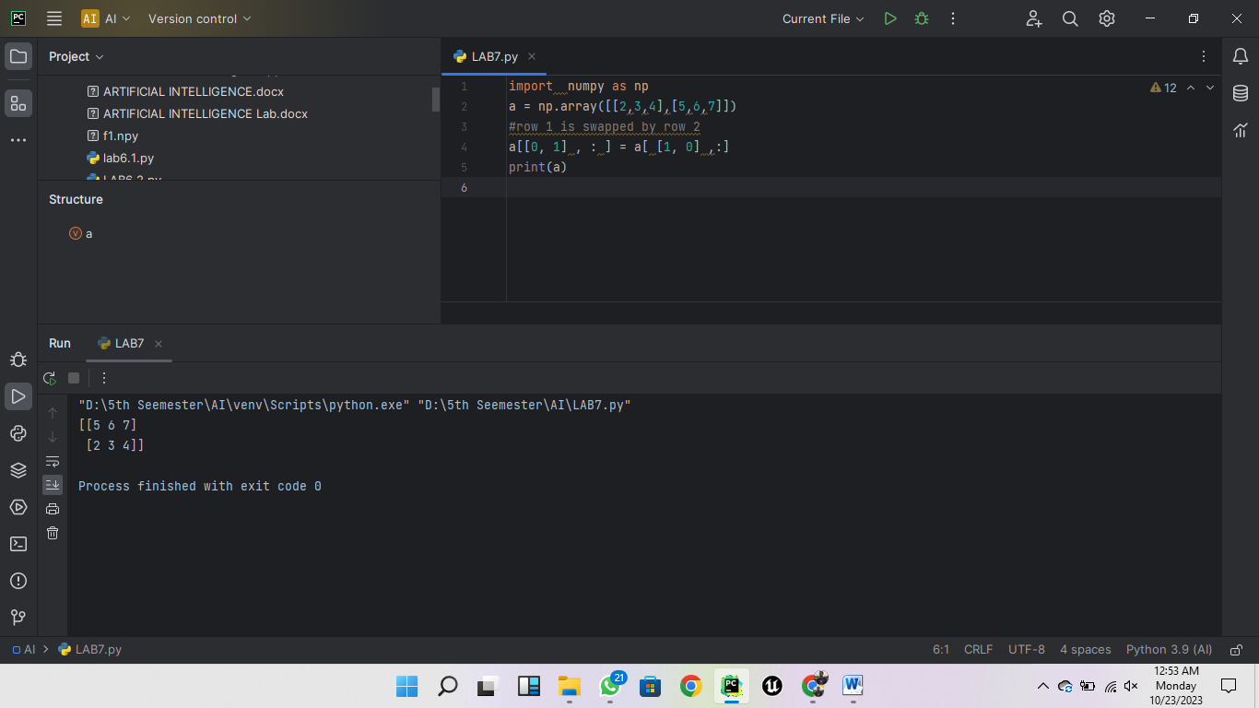

1. [**How to reverse the rows of a 2D array?**](https://www.kaggle.com/python10pm/learn-numpy-the-hard-way-70-exercises-solutions#q18)

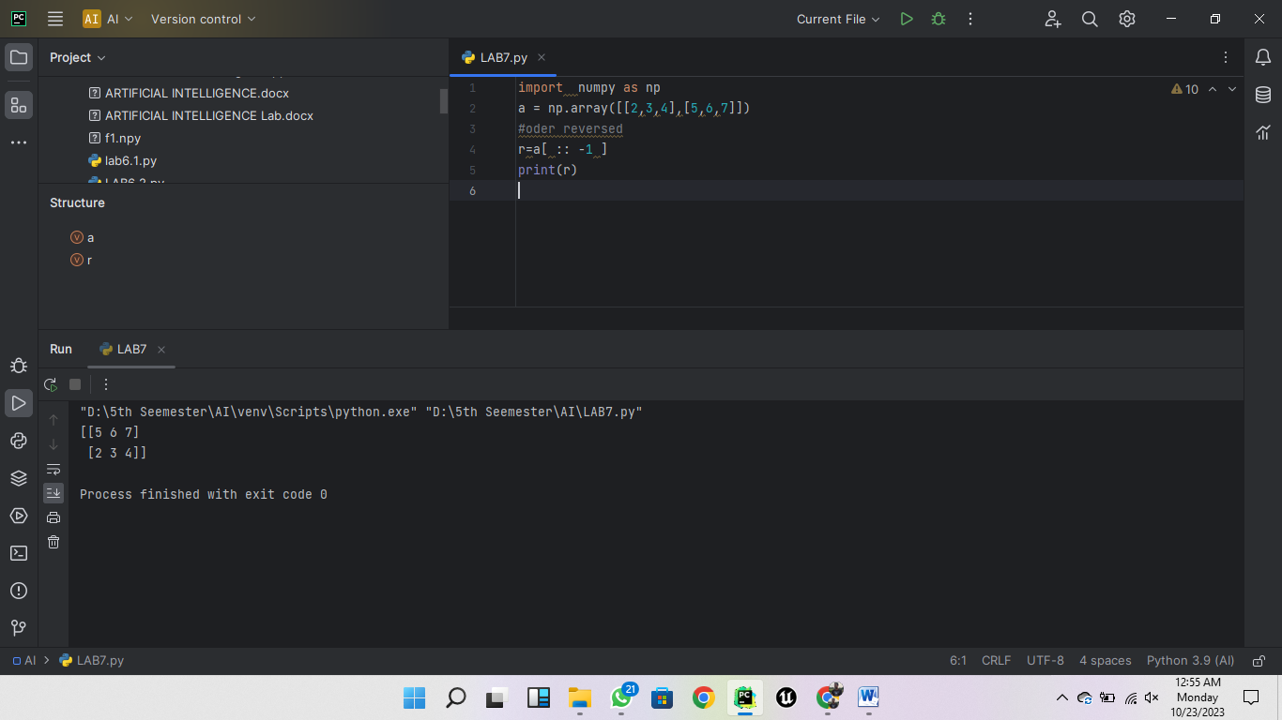

1. [**How to reverse the columns of a 2D array?**](https://www.kaggle.com/python10pm/learn-numpy-the-hard-way-70-exercises-solutions#q19)

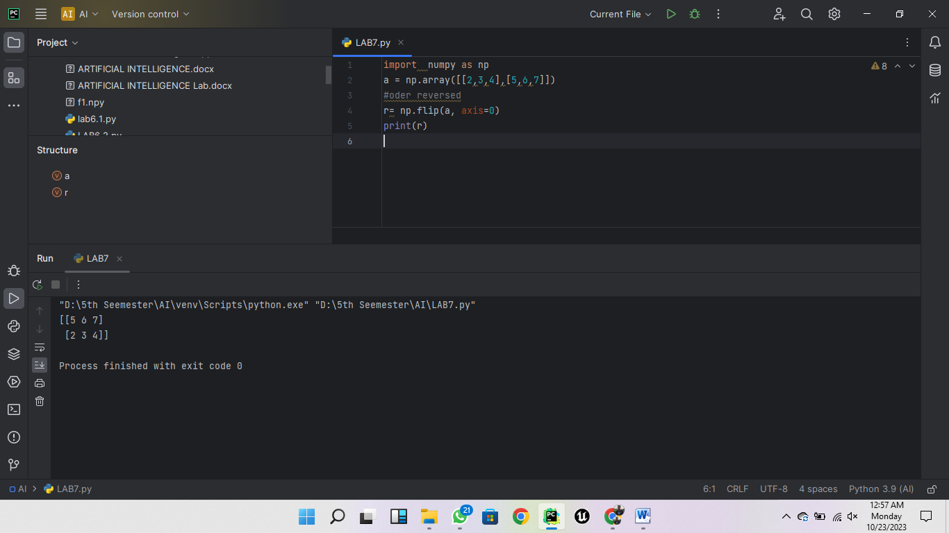

1. [**How to create a 2D array containing random floats between 5 and 10?**](https://www.kaggle.com/python10pm/learn-numpy-the-hard-way-70-exercises-solutions#q20)

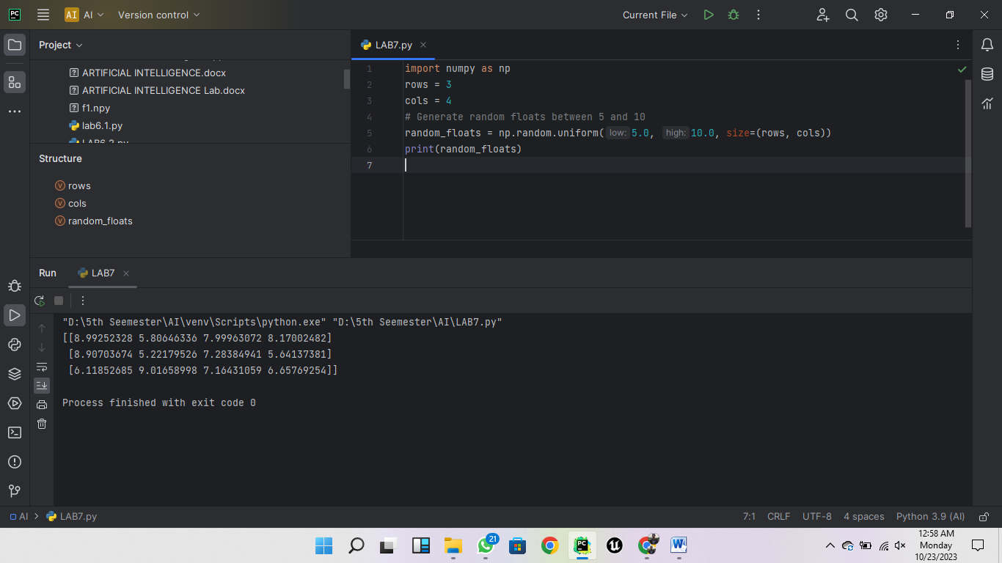

1. [**How to print only 3 decimal places in python numpy array?**](https://www.kaggle.com/python10pm/learn-numpy-the-hard-way-70-exercises-solutions#q21)

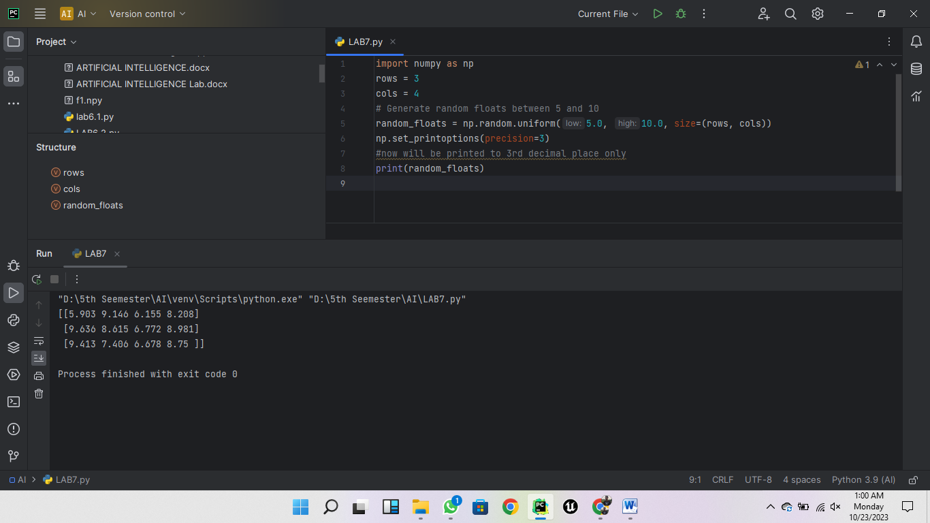

1. [**How to pretty print a numpy array by suppressing the scientific notation (like 1e10)?**](https://www.kaggle.com/python10pm/learn-numpy-the-hard-way-70-exercises-solutions#q22)

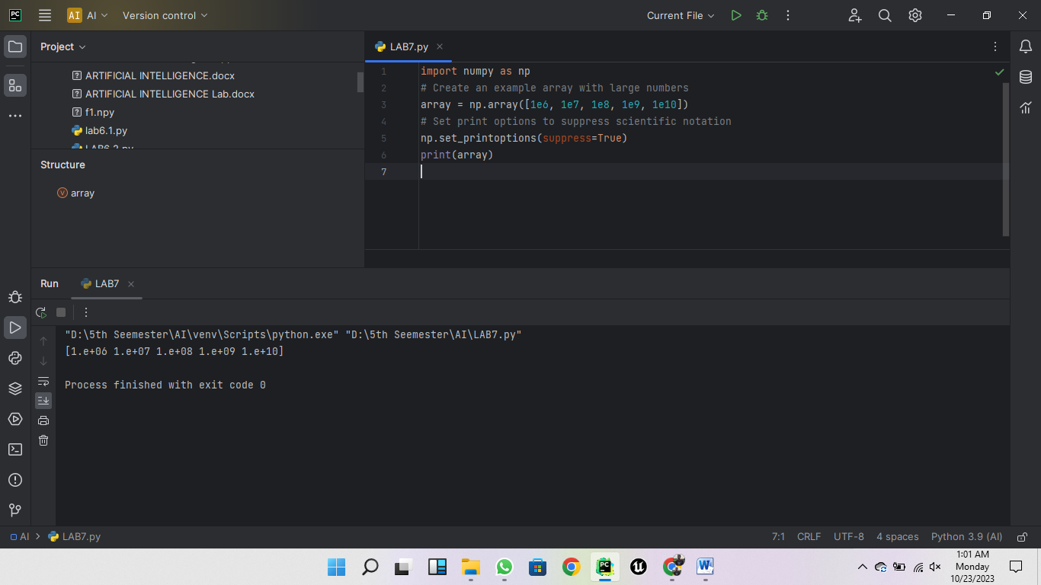

1. [**How to limit the number of items printed in output of numpy array?**](https://www.kaggle.com/python10pm/learn-numpy-the-hard-way-70-exercises-solutions#q23)

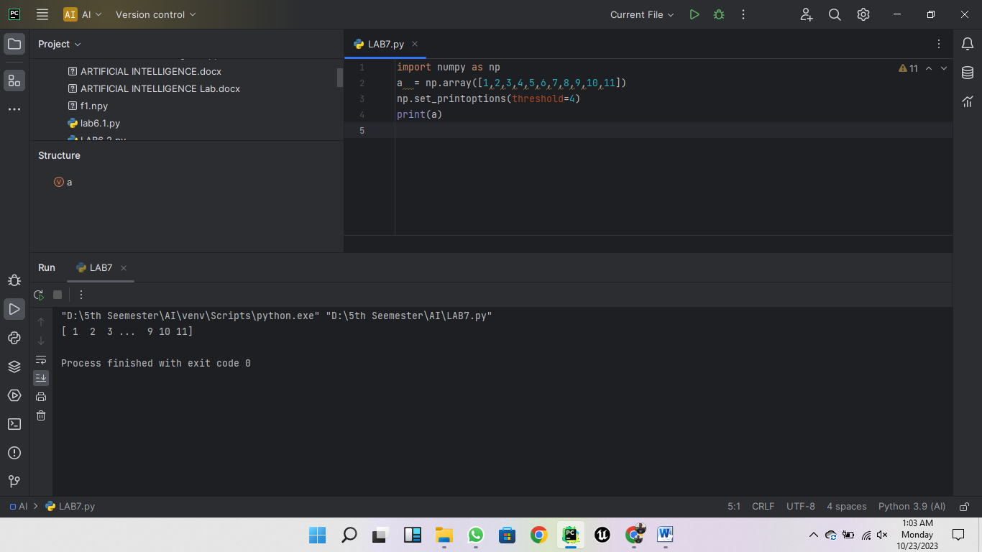

1. [**How to print the full numpy array without truncating**](https://www.kaggle.com/python10pm/learn-numpy-the-hard-way-70-exercises-solutions#q24)

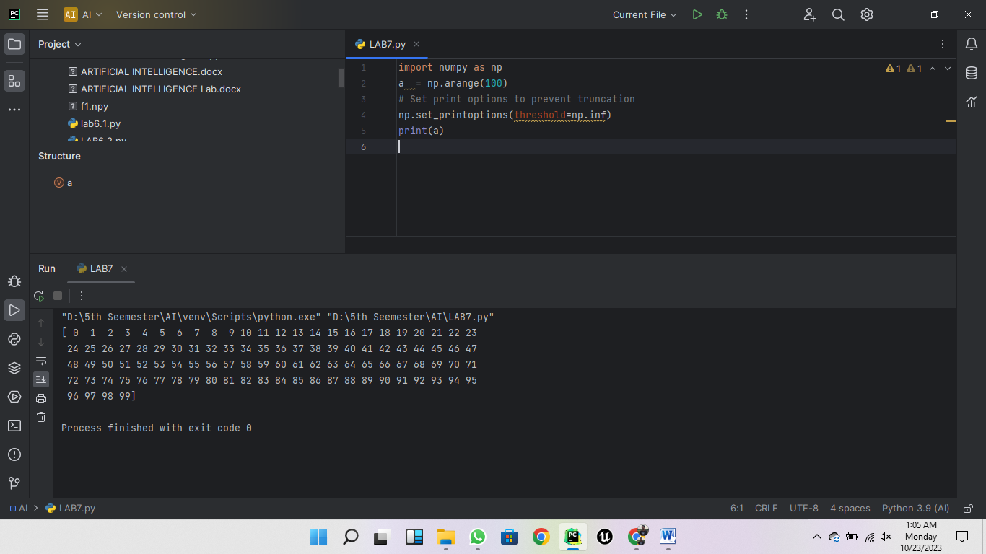

1. [**How to import a dataset with numbers and texts keeping the text intact in python numpy?**](https://www.kaggle.com/python10pm/learn-numpy-the-hard-way-70-exercises-solutions#q25)

